WEB PHISHING DETECTI0N

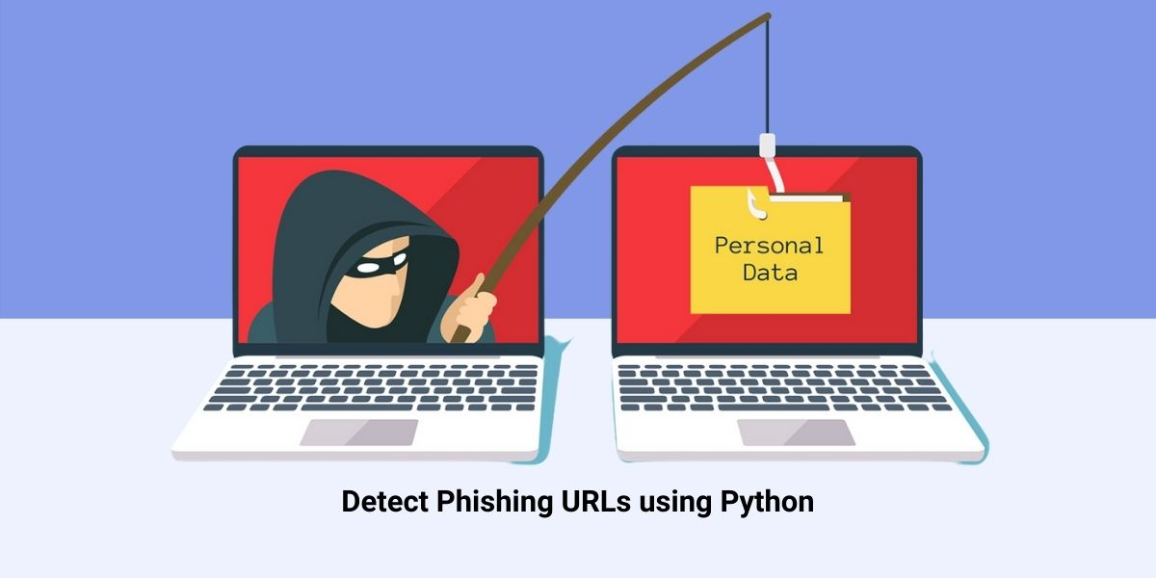

**SOLUTION ARCHITECTURE**

***TEAM DETAILS***

*TEAM NUMBER : PNT2022TMID34399*

*COLLEGE NAME : CAPE INSTITUTE OF TECHNOLOGY*

*DEPARTMENT : INFORMATION TECHNOLOGY*

**PROBLEM MEMBERS**

* ISWARYA.A
* PARVATHY.T
* SALINI.T
* SAHAYA ABISHA.A



SOLUTION ARCHITECTURE:

Solution architecture is a complex process – with many sub-processes – that bridges the gap between business problems and technology solutions. Its goals are to:

* Find the best tech solution to solve existing business problems.
* Describe the structure, characteristics, behavior, and other aspects of the software to project stakeholders.
* Define features, development phases, and solution requirements.
* Provide specifications according to which the solution is defined, managed, and delivered.

SOLUTION ARCHITECTURE DIAGRAM:

